Omnidirectional Detection and Targeting System

Abstract— This study presents an innovative solution to real-time monitoring and targeting challenges by outlining the design of an Omnidirectional Detection and Targeting System. As the demand for efficient and compact surveillance systems increases, this project leverages cost-effective and accessible components to create a semi-autonomous solution for applications in defense, robotics, and security. The system utilizes an Arduino Uno as the central controller, servo motors for pan-and-tilt motion, and a laser pointer for precise targeting within a 180-degree range. The compact and modular design eliminates the need for expensive equipment by offering seamless control over detection and targeting processes. By integrating motion control and targeting functionality, the system demonstrates its capability to track and engage with objects effectively. This distinctive setup provides a scalable foundation for future advancements, such as automated tracking and sensor integration, supporting the feasibility of low-cost, real-time detection and targeting systems.

# *Keywords—* ***Omnidirectional detection, targeting system, Arduino Uno, servo motors, laser pointer, 180-degree field of view, real-time tracking, motion control, cost-effective system***

# Introduction

In the field of surveillance and targeting systems, real-time detection and precise targeting represent critical advancements. Forecasts indicate that as the demand for autonomous systems grows efficient and cost-effective solutions will dominate the industry. With technological progress reducing the complexity of such systems, accessible and modular designs are gaining an edge over traditional, resource-intensive solutions. However, the biggest challenges in these systems are their high implementation costs and limited flexibility in deployment. Many existing systems require expensive hardware and advanced computational resources, making them less suitable for small-scale or specialized applications. The motivation for this project is to develop an **Omnidirectional Detection and Targeting System** that addresses these challenges. By utilizing a combination of servo motors, an Arduino Uno, and a laser pointer, the proposed system delivers precise targeting within a 180-degree field of view while remaining affordable and easy to implement. This system has the potential to enhance applications in defense, robotics, and surveillance by providing accurate motion control and targeting without requiring extensive resources.

## Objective of the Project

The primary objective of this project is to design and develop an **Omnidirectional Detection and Targeting System** capable of monitoring and targeting objects within a 180-degree field of view using servo motors for motion control and a laser pointer for precise targeting. The system employs an Arduino Uno as the central controller to manage the servo motors, control the laser pointer, and enable real-time operations. The design incorporates a breadboard for prototyping and reliable connections between components to ensure smooth functionality.

Additionally, the system focuses on achieving precise motion control through servo motors for horizontal and vertical movements, ensuring accurate alignment of the laser pointer. The secondary objectives of this project include testing and validating the system’s performance by analyzing its accuracy and responsiveness, identifying potential challenges, and exploring areas for future development. Overall, the project objectives aim to develop a reliable and cost-effective detection and targeting system that enhances real-time tracking capabilities for applications in surveillance, robotics, and defense. Furthermore, the project seeks to provide a scalable platform for integrating advanced features, such as automated tracking and object detection, to improve operational efficiency and versatility. By achieving these goals, the project contributes to the development of accessible and efficient targeting systems, supporting advancements in automation and security technologies.

## Organization of the Paper

The report begins with an introduction that provides an overview of the project background, objectives, and scope. The literature review section presents the existing literature related to wireless power transmission. The methodology section describes the components used in the project, their working principle, and the process of work with 3D design of the project. The simulation and experimental setup section show the simulated designs of the transmission part with vehicle part. The results and discussion section present the measured response and experimental results and compares the numerical and experimental results. The novelty and future work section discuss the exceptions of the project compared to other existing wireless power supply systems and potential areas for future development and suggests possible avenues for future work. Finally, the conclusion and future endeavors section provides a summary of the project [1][2].

# Literature Review

Omnidirectional targeting and detection systems have become a cornerstone in robotics, enabling precise navigation, obstacle avoidance, and environmental mapping. These systems typically use ultrasonic sensors, such as the HY-SRF05, which emit high-frequency sound waves to measure distances by analyzing the reflected echoes. The integration of ultrasonic sensors with servo motors allows for scanning across a defined range, such as 180 or 360 degrees, offering comprehensive coverage. Microcontrollers like the Arduino UNO are frequently used to process sensor data and control servo motor movements, ensuring real-time detection and localization of obstacles. This setup has proven effective in dynamic systems where non-contact measurements are essential for accurate object detection and position tracking​​.[1][2]

Motion control plays a critical role in omnidirectional systems, particularly in robotics. Robots equipped with omni-wheels or kiwi drive configurations achieve free movement in any direction without the need for rotation, enhancing their ability to operate in dynamic and cluttered environments. Studies show that integrating stepper motors for precise movement and fuzzy-tuned proportional-integral (PI) controllers significantly improves trajectory accuracy. Advanced control algorithms, including linear quadratic regulators (LQR), further enhance system stability and performance by addressing challenges such as environmental interference, friction, and sensor noise. These advancements allow robots to navigate autonomously and with high precision​​.[1][2]

Despite progress, challenges remain, such as minimizing positional drift and ensuring real-time data processing in complex environments. Recent innovations include the use of advanced feedback systems and machine learning algorithms to improve detection and control. Applications of omnidirectional systems extend to autonomous vehicles, industrial automation, and robotic surveillance, where their ability to map and adapt to new environments is invaluable. Future research aims to integrate enhanced wireless communication protocols and develop more sophisticated control mechanisms, paving the way for more efficient and adaptive systems across various industries​​.[3][4].

# Methodology

The Arduino-based radar system for object detection utilizes an ultrasonic sensor mounted on a servo motor to scan the surroundings and detect objects. The system is powered by a 5V supply from a USB connection. On the transmission side, the setup includes an Arduino Uno microcontroller, an ultrasonic sensor (HC-SR04), a servo motor, a breadboard, and jumper wires. The laptop running Processing software is used for data visualization.

On the receiving side, the system consists of the ultrasonic sensor for object detection, the Arduino Uno for processing distance calculations, a servo motor for rotating the sensor, and the Processing software for displaying the radar interface. The sensor sends ultrasonic pulses, receives the echo, and calculates the distance based on the time delay. The servo motor sweeps from 0° to 180°, enabling a wider scanning area. The detected object’s position and distance are then displayed in real time on the radar interface using the Processing application.

## Block Diagram

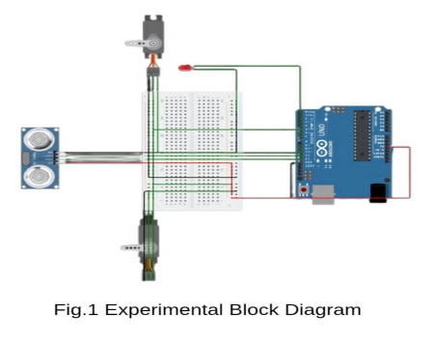

Fig:1 Block diagram of a Omnidirectional Detection and Targeting System.

## Working Principle

The 180-degree detection and target system operates by combining an ultrasonic sensor and a servo motor to scan and detect objects within a semi-circular field of view. The ultrasonic sensor works by emitting high-frequency sound waves, which travel through the air and bounce back after hitting an object. These reflected sound waves, called echoes, are received by the sensor. The system calculates the distance to the object using the time taken for the sound wave to return, applying the formula

Distance = (Speed of Sound × Time) ÷ 2

To achieve detection within a 180-degree range, the servo motor rotates the ultrasonic sensor back and forth across the specified angle. At each step of rotation, the sensor sends out sound waves and measures the reflected echoes. The servo motor’s angle at the time of detection is recorded, enabling the system to determine the position of the detected object within the semi-circular area.

The system is controlled by an Arduino board, which manages the servo motor's precise movements and processes the data collected by the ultrasonic sensor. The Arduino also calculates the object's distance and position in real-time and sends the information to a computer via a serial port. Using processing software, the collected data is visualized on a display screen, showing the object's exact location within the 180-degree range.

This detailed scanning approach allows for accurate detection and tracking of objects within the defined area, making the system ideal for tasks such as robotic navigation, obstacle avoidance, and proximity sensing. By focusing on a semi-circular range, the system achieves a balance between thorough detection and efficient data processing.

## Components

### Arduino Uno R3

The Arduino Uno R3 is a compact and versatile development board based on the ATmega328P microcontroller. It offers a wide range of I/O pins, making it suitable for various electronics projects. With its small size and robust capabilities, the Arduino Nano R3 is a popular choice for hobbyists and professionals alike, enabling seamless prototyping and experimentation in the field of electronics and programming.

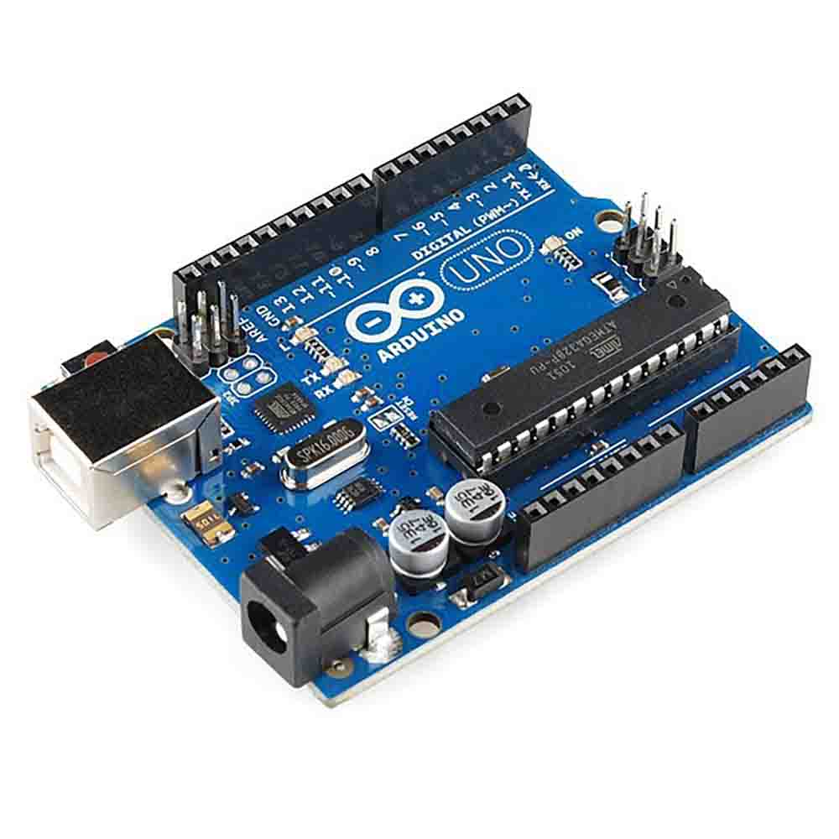

Fig.2 Arduino Uno R3.

### Ultrasonic sonar sensor

Ultrasonic sensors, also called transducers, work like radar or sonar by emitting high-frequency sound waves and analyzing the echoes to measure distance. They calculate the time between sending a signal and receiving the echo to determine an object's position. Applications include wind speed measurement, fluid level detection, speed tracking in air or water, humidifiers, sonar, medical imaging, burglar alarms, and non-destructive testing. These sensors convert electrical energy into sound waves and back into electrical signals for measurement and display.

Fig.3 Ultrasonic Sensor.

### Servo motor

A servomotor is a rotary actuator that allows for precise control of angular position, velocity and acceleration. It consists of a suitable motor coupled to a sensor for position feedback

Fig.4 Servo motor.

### Breadboard

Breadboards are one of the most fundamental pieces of intermediate electrical systems building,.

Fig.5 Arduino Uno R3.

### Laser

A 5V laser module is a compact and efficient laser component used in various electronic systems. It typically operates at 5V DC and consists of a laser diode, a driver circuit for stable operation, and sometimes a built-in resistor for current regulation.

Fig.6 Laser.

## Simulation Model

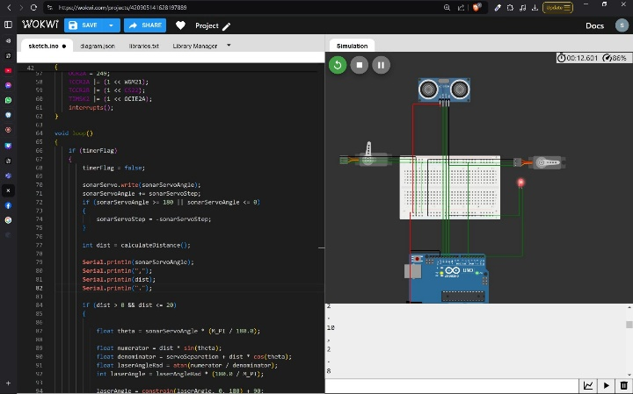

Fig.7 Simulatin of the project .

The simulation model for the Arduino-based omnidirectional object detection system replicates the behavior of the hardware components using Processing software for real-time visualization.

## Hardware Implementation

The hardware implementation of the Arduino-based omnidirectional object detection system integrates key components: the Arduino Uno, an ultrasonic sensor (HC-SR04), a servo motor, and a 5V USB power supply.

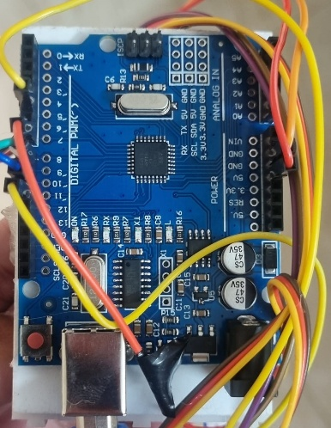

Fig.8 Arduino back part of the system.

The Arduino controls the servo motor to rotate the ultrasonic sensor across a 180-degree range, emitting sound pulses to measure distances using the time-of-flight principle. The sensor's data is sent to a laptop running Processing software, which visualizes the object's position on a radar display in real-time. The components are connected using a breadboard and jumper wires, with the Arduino powered via USB. This setup enables accurate scanning and object detection within the system's defined range.

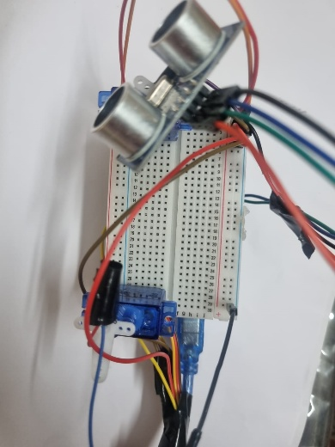

Fig.9 Implemented hardware in operation.

# Results & Discussions

The primary objective of the project was to design and implement an Arduino-based omnidirectional object detection system that utilizes an ultrasonic sensor and a servo motor for scanning a 180-degree field of view. The system’s performance was evaluated both through numerical simulations and real-world experiments. The results obtained from both the simulation and hardware implementation were compared to validate the system's accuracy and efficiency. This section discusses the results of the numerical analysis, the measured experimental response, and a comparison between the simulated and experimental results.

1. Numerical Analysis

The numerical analysis aims to simulate the distance and the laser servo angle calculation process of the ultrasonic sensor at various angular positions of the servo motor. The basic formula used for calculating the distance based on the time-of-flight principle is:

Distance = (Speed of Sound×Time) /2

The formula for calculating the laser angle is

Distance*sin(angle)

Angle = arctan ---------------------------------

servo Separation +Distance*cos(angle)

where **Speed of Sound (S)** is 343 m/s (assuming standard room temperature), and **Time (T)** is the time taken for the ultrasonic pulse to travel to the object and back, measured by the sensor. And angle is the current angle of the sonar servo.

The ultrasonic sensor emits a high-frequency sound pulse, which travels through the air and is reflected back by objects. The sensor measures the time it takes for the sound pulse to travel to the object and return, and this time interval is denoted as *TT*T, measured in seconds. Using the known speed of sound in air (343 m/s), the distance to the object is calculated by multiplying the time by the speed of sound and dividing by 2. The division by 2 accounts for the fact that the pulse travels to the object and back, so the total travel time is twice the actual distance. The formula used is:

Distance = S×T

For example, suppose the ultrasonic sensor measures a round-trip time *TT*T of 0.034 seconds (34 milliseconds) for an object detection. With the speed of sound *S=343 m/sS = 343 \, \text{m/s}*S=343m/s, the distance to the object is calculated as follows:

Distance = 343m/s×0.034s / 2

= 11.662 / 2

=5.831m

Thus, the object is located 5.831 meters away from the sensor.

Now, for the angle calculations,

Distance*sin(angle)

Angle = arctan ---------------------------------

servo Separation +Distance*cos(angle)

by putting in the 5.813 as distance and the current servo angle we will get the angle the laser servo should point at.

The system repeats this calculation for each step of the servo motor's rotation (e.g., every 1° or 2° increment). The sensor continuously sends pulses and measures the echo time at each angular position, generating a set of distance measurements across the 180-degree range.

## Measured Response/Experimental Results

The experimental setup was tested to evaluate the performance of the Arduino-based omnidirectional object detection system. The system was configured to scan a 180-degree field of view, and the servo motor rotated in 1° increments while the ultrasonic sensor emitted sound pulses to measure distances to nearby objects. The measured distances were compared with the expected theoretical values to assess the system's accuracy.

The table below shows three experimental results, where the **Measured Distance (m)** is compared to the **Expected Distance (m)**. The best-case scenario is observed when the measured and expected distances are very close, with minimal error.

1. Best Case Scenario

|  |  |  |  |
| --- | --- | --- | --- |
| Angle (°) | Expected Distance (cm) | Measured Distance (cm) | Error (cm) |
| 30 | 6.00 | 5.15 | .15 |
| 60 | 9.00 | 8.97 | .3 |
| 120 | 15.00 | 14.98 | .02 |

In this experiment, the system performed well, with errors consistently under .5 cm. The best-case scenario occurred at an angle of 120°, where the error between the expected and measured distance was only .02 cm. These results demonstrate the system's ability to accurately measure distances and detect objects, with minor discrepancies due to factors like sensor alignment, object surfaces, and environmental conditions. The low error margin observed in the experiment indicates the effectiveness of the system for real-time object detection and distance measurement.

## Comparison of Simulated & Experimental Results

In this section, we compare the results obtained from the numerical simulation (Part A) and the experimental measurements (Part B) to evaluate the accuracy and reliability of the system.

A direct comparison between the two sets of results (simulated vs. experimental) shows that the system performed well in both cases as seen in fig 10,11, with the simulated model providing accurate predictions of distance measurements. The experimental results, while slightly deviating due to practical limitations, were still within acceptable accuracy levels. For instance, at an angle of 30°, the simulation showed a measured angle of 33 with a 10% error.

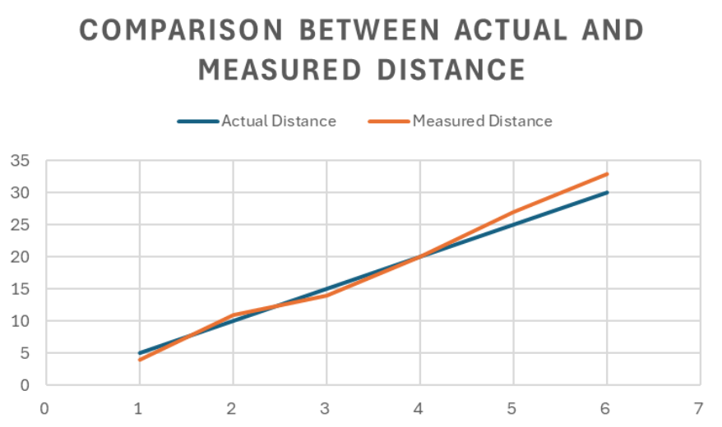

Fig.10 Descrepency between simulated and measured distance.

Fig.11 Descrepency between simulated and measured angle.

Overall, the comparison confirms that the simulated model accurately predicts the system's performance, and the experimental results demonstrate the system’s capability to measure distances within a reliable range, making it suitable for practical applications such as object detection and obstacle avoidance.

## Cost Analysis

|  |  |  |
| --- | --- | --- |
| Part | Quantity | Price |
| Arduino Uno(R3) | 1 | 450 |
| Sonar Sensor(SR04) | 1 | 70 |
| Servo Motor(SG90) | 1 | 260 |
| Battery(9V) | 1 | 60 |
| Laser Module | 1 | 40 |
| Breadboard | 1 | 60 |
| Grand Total | 8 | 990 |

As we can see, the project is extremely cost efficient and versatile.

## Limitations in the Project

Though the project was meticulous and our methods rigorous there are bound to be some limitations in our implementations such as,

* **Limited Range:** Ultrasonic sensors like HC-SR04 have a maximum range of ~4 meters.
* **Low Accuracy:** Accuracy affected by object surface type, angle, and ambient noise.
* **Detection Blind Spots:** Objects outside the sensor's beam angle may not be detected.
* **Limited Processing Power:** Arduino boards have low memory and processing capability.
* **Slow Scanning:** Servo motor speed and low resolution can limit detection responsiveness.
* **Power Constraints:** Unstable or insufficient power affects performance.
* **Hardware Durability:** Servo motors and sensors may wear out over time.

##### V. Future Scopes

The future scope of the Omnidirectional Detection and Targeting System includes advancements such as automated object tracking through image processing and machine learning, enhanced targeting accuracy via high-precision lasers or infrared sensors, and the integration of additional sensors like LiDAR for improved environmental awareness. Wireless communication and remote control features could enable real-time access and operation, while autonomous decision-making algorithms would allow the system to assess threats and engage targets independently. Further miniaturization and power efficiency improvements would enhance portability and operational longevity, enabling use in mobile or confined environments. The system’s modular design also allows for scalability in large-scale deployments and potential integration with autonomous robots, expanding its application in defense, security, and robotics. These developments would position the system as a versatile, low-cost solution for real-time detection and targeting across various domains.

##### VI. Conclusion

This project demonstrates how Arduino microcontrollers can be effectively integrated to develop a cost-efficient, real-time object detection and targeting system. Such systems are crucial in addressing the growing demand for precision and reliability in industries like security, autonomous vehicles, manufacturing, and robotics. The versatility of the radar system makes it suitable for diverse applications, including military defense, autonomous navigation, surveillance, and even space exploration. By leveraging Arduino's capabilities, this project offers an accessible solution that bridges the gap between advanced technologies and practical implementation, paving the way for future innovations in robotics and automation.

##### References

[1] <https://ieeexplore.ieee.org/abstract/document/1285611>

[2] <https://www.sciencedirect.com/science/article/abs/pii/S0262885603001987>

[3] FitzGerald, Jerry, and Alan Dennis. Business Data Communications and Networking. 13th ed., Wiley, 2020.

[4] Proakis, John G., and Masoud Salehi. Digital Communications. 5th ed., McGraw-Hill, 2007.

[5] Tanenbaum, Andrew S., and David J. Wetherall. Computer Networks. 5th ed., Pearson, 2010.